Q25 A program processes deeply nested expressions. Construct a concept map linking Recursion Depth →Call Stack → Memory Usage → Stack Overflow → Efficiency. Analyze the risks of deep recursion and evaluate alternative approaches.

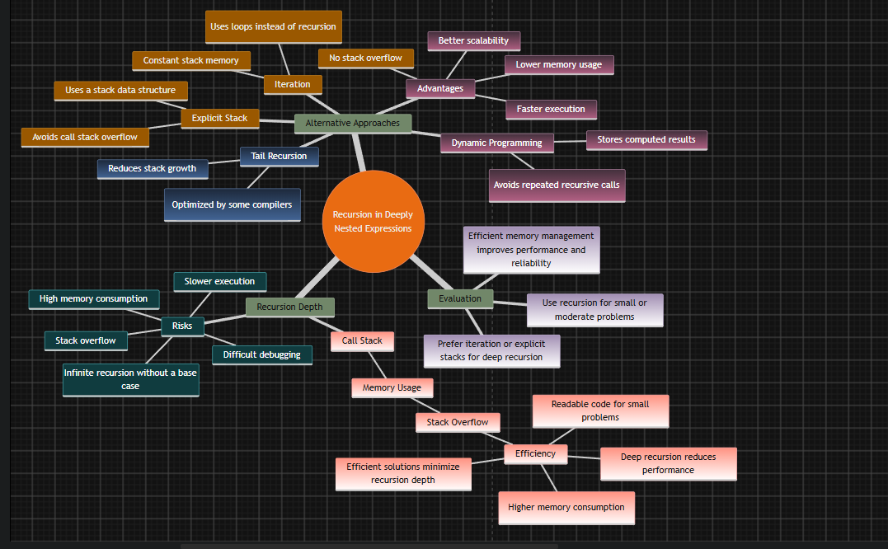

Q5 A mobile application operates under strict memory constraints while processing large datasets. Construct a concept map linking Memory Usage → Space Complexity → Auxiliary Space → Input Size→ Algorithm Efficiency. Include examples of algorithms with varying space complexities and explain how memory limitations influence the selection of data structures and algorithms. Justify how efficient memory usage improves system performance.

